King Saud University

College of Engineering

Industrial Engineering Department

By:

Muhammad Dzulqarnain Al Firdausi

(438106660)

Submitted to:

Dr. Abdulaziz Al-Tamimi

**Facilities Analysis & Design**

**IE 550**

**Blocplan Algorithm**

**Table of Contents**

**Table of Contents** 2

**List of Figures** 3

**List of Tables** 4

**1.** **Introduction** 5

**2.** **Literature review** 5

**3.** **BLOCPLAN** 7

**3.1.** **Overview** 7

**3.2.** **Methodology** 8

**3.3.** **BLOCPLAN development** 14

**4.** **Study Case** 19

**4.1.** **Problem Statement** 19

**4.2.** **Collecting data** 19

**4.3.** **Using the new version of BLOCPLAN** 21

**4.4.** **Result comparison** 28

**4.5.** **Discussion** 29

**6.** **References** 30

**APPENDIX** 31

**List of Figures**

Figure 1 Blocplan Algorithm Flowchart 8

Figure 2 Department Placement 9

Figure 3 Sub-dividing 9

Figure 4 Relationship Chart 10

Figure 5 Automatic search algorithm 10

Figure 6 Input department data form 15

Figure 7 Relationship chart input 16

Figure 8 Score for each code 17

Figure 9 Relationship score calculation for each department 18

Figure 10 Length width ratio for layout 18

Figure 11 Layout generation with random layout algorithm [4] 19

Figure 12 Production line of the company 20

Figure 13 Cell data of the ammunition division 22

Figure 14 Relationship chart of the company 23

Figure 15 Score for each relationship code 24

Figure 16 Score for each relationship code 25

Figure 17 Ratio selection 26

Figure 18 Initial layout from blocplan 27

Figure 19 Improved layout 27

**List of Tables**

Table 1 Literature review 6

Table 2 BLOCPLAN pros and cons 7

Table 3 Code for Relationship Chart and its score 9

Table 4 Area of each machine cell 20

Table 5 Relationship chart for ammunition division 21

Table 6 R.Score comparison 29

1. **Introduction**

Facility layout problem (FLP) is a fundamental problem which seeks to reduce material handling costs, work in process, lead times, utilize existing space more effectively, make plant adaptive to future changes, provide a healthy, convenient and safe environment for employees, and generally increase productivity through determining an efficient arrangement (layout) of the required facilities within the organization. This problem has many applications in real life situations.

However, the main attentions of the research in this area have been focused on the manufacturing applications. It is noteworthy to know that material handling cost constitutes 20–50% of the total operating expenses in manufacturing environments which can considerably be reduced through designing an efficient layout configuration. Material handling cost is mainly dependent on the amount of material flow and distances between locations of the facilities. Accordingly, minimizing the material handling cost has been considered as the common objective in the literature [8].

In other hand, although most facility layout programs seek the layout that will attempt to minimize the material handling activity for the problem, this objective approach to the problem is not the only solution technique that may apply in many situations. There may be other factors that have to be considered. There could be vibration problems that occur in some department that make it impractical for it to be near another department. Similarly, it would be undesirable to locate a painting department near a grinding or machining department. These factors can very often enter into the layout design. There are other scoring procedures to evaluate a layout and the results obtained from these procedures can be calculated and displayed for each layout that is created.

Facility layout involves the arrangement of departments in a facility. The objective of facility layout analysis is to develop layouts which maximize the advantageous placement while minimizing the disadvantageous placement of departments. Computers have been utilized since the 1960’s and 1970’s to assist with the high computational demands required for the calculations necessary for producing these types of facility layouts.

1. **Literature review**

The table below shows literatures related to facility layout problem.

Table 1 Literature review

| **No.** | **TITLE** | **DESCRIPTION & ABSTRACT** | **TECHNIQUE** | **Year of Publication** |
| --- | --- | --- | --- | --- |
| 1 | Production facility layout by comparing moment displacement using BLOCPLAN and ALDEP Algorithms (M Tambunan) | The purpose of this study is comparing movement displacement using BLOCPLAN and ALDEP algorithm in order to redesign existing layout. | BLOCPLAN and ALDEP | IOP Conference Series: Materials Science and Engineering 309 012032 (2018) |
| 2 | Blocplan for windows: Computer aided facility layout methodology and enhancements (Donaghey) | BLOCPLAN for Windows is an evolutionary development of its DOS version. It is able to result more alternative layout, e.g. for a nine department problem the number of possible layouts is close to 20 million | BLOCPLAN | Proceedings of the 2007 Industrial Engineering Research Conference |
| 3 | FLEXPERT: facility layout expert system using fuzzy linguistic relationship codes (Badiru) | An expert system generates facility layout alternatives based on the fuzzy logic theory and the results provided by BLOCPLAN (software for buildingplant layouts) | BLOCPLAN  Fuzzy Logic | IIE Transactions, 28, 295–308 (1996) |
| 4 | Production facility layout design using blocplan algorithm (Puspita) | The implementation of the BLOCPLAN algorithm to **improve** the production **facility** **layout**. Total movement moment and the Benefit-cost ratio (BCR) are used to compare existing and alternative layout | Benefit-cost ratio (BCR)  Blocplan | American Scientific Publishers (2015) |
| 5 | Comparing alternative plant layouts based on Craft and Blocplan algorithms (Leonardo) | The paper **compares** two proposed layout models using CRAFT and BLOCPLAN algorithms. An initial layout is analyzed and the two algorithms are applied to the layout therefore the best score resulted from a layout is selected. | Craft and Blocplan | Metris Journal Vol. 15 (2014) 55–64 |
| 6 | An interactive layout heuristic based on hexagonal adjacency graphs (Goetschalckx) | The paper presents an efficient and interactive two-stage heuristic for the generation of block layouts. | Optimization, Graph algorithms, Block layout algorithms | European Journal of Operational Research 63 (1992) 304-321 |

1. **BLOCPLAN**
   1. **Overview**

BLOCPLAN is an interactive program developed by Donaghey and Pire (1991) that can develop a single-story or multistory layout and has a number of useful features. It offers a number of heuristic algorithms for solving the layout problem and can handle quantitative as well as qualitative data. It allows the user to enter product routing data. BLOCPLAN provides ample opportunity to view and edit data. The user provides flow data in the form of a relationship chart, which is then used to develop a layout.

The literature review which has been done and software testing of BLOCPLAN algorithm (BPLAN90.exe) give the author several insights related to the pros and cons of the algorithm [9].

Table 2 BLOCPLAN pros and cons

| **Pros** | **Cons** |
| --- | --- |
| * Providing the square shape for each department * Resulting up to 20 alternatives with different scores for a layout * Combining qualitative and quantitative data * Able to change the position of departments manually | * 3 tiers may be limiting * Can lead to poor department shapes (long and skinny departments) * Not providing the total movement score for a layout |

The DOS version of BLOCPLAN allows user to input product data and their department sequence. However, the software is not providing the total movement score. Puspita work [7] count the total movement score manually which it should be provided by BLOCPLAN automatically.

* 1. **Methodology**

The user provides the **required area** for the layout that is to be created. He/she does this by specifying the number of "departments" that are to be included in the layout, and then gives the names and required areas for each of these departments. The system will find the total area for all of these departments, and this will be the required area for the layout.

The user also gives the desired **length to width ratio** (L/W) for the layout. This is the L/W ratio for the entire facility that will contain the departments. This allows for efficient aisle placement and materials handling. The **length and the width** of the facility can be calculated using the L/W ratio and the total area. BLOCPLAN uses tiers and zones to develop a layout.



Figure 1 Blocplan Algorithm Flowchart

The facility is divided into **three tiers** (bands) containing three zones each. The top tier has zones A, B, and C. The mid-tier has zones D, E, and F. The third or bottom tier has zones G, H, and I [4].

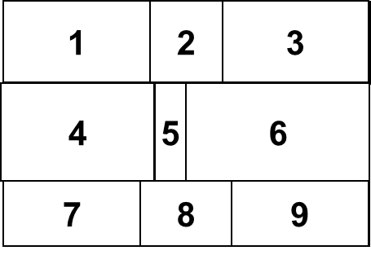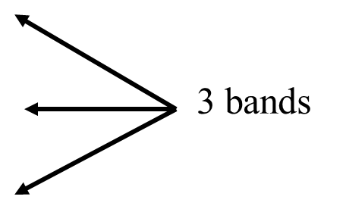

Figure 2 Department Placement

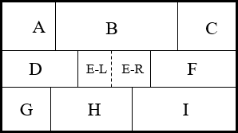**Each zone is also sub-divided into two sub-zones**, L and R. AL refers to the area in the left portion of zone A, and AR refers to the right side of zone A. Using this notation there are 6 positions that departments can use in Tier 1, 6 positions for Tier 2, and 6 positions for Tier 3.

Figure 3 Sub-dividing

**BLOCPLAN utilizes the Relationship chart** method. With this relationship chart method, a user examines each pair of departments and makes a judgment of how important it is that the pair of departments be close together. Certainly, the amount of material handling between the departments is a factor in this judgment. Muther used the A, E, I, O, U, and X codes. An A relationship indicated that it was "Absolutely Essential" that the departments be close, an E relationship meant that it was "Essential", an I meant that it was "Important", an O means "Ordinary Closeness OK", a U indicated that closeness is "Unimportant", and an X meant that it was "Undesirable" to have them close [2].

Table 3 Code for Relationship Chart and its score

|  |  |  |
| --- | --- | --- |
| **Code** | **Description** | **Score** |
| A | Absolutely Essential | 10 |
| E | Essential | 5 |
| I | Important | 2 |
| O | Ordinary Closeness OK | 1 |
| U | Unimportant | 0 |
| X | Undesirable | -10 |

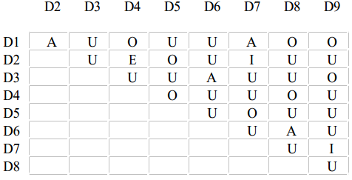

Figure 4 Relationship Chart

The desired relationship chart shown in Figure 4 has four 4 A’s, 1 E, 2 I’s, 1 E, 8 O’s, and 21 U’s. Suppose the worth vector of the codes are A: 10, E: 5, I: 2, O: 1, U: 1, X: -10. Therefore, the total worth of all the positive relationship codes for the problem is 57.

If a user has material handling information concerning a layout, this information can be converted to a relationship chart by BLOCPLAN. It shows material handling activity, in Moves/Time Period, between each pair of departments. BLOCPLAN can develop a Muther type relationship chart from this data. It takes the maximum number of loads between departments in the chart and divides this value by 5. For the nine department layout of Figure 2, suppose the maximum number of loads is 300. Depts 3 and 6 and Depts 6 and 8 each have 300 loads per time period between them. Thus, 300/5 = 60. A relationship code of "A" would be assigned to pairs of departments that have a From/To value in the inclusive interval [241, 300]. An "E" would be assigned for values in the inclusive interval [181, 240], an "I" for values within the interval [121, 180], an "O" for the interval [61, 120], and a "U" for values that are equal to or less than 60. There would be no "X" values (Undesirable) assigned for the chart.



Figure 5 Automatic search algorithm

BLOCPLAN can develop a layout randomly or using an automatic search algorithm (Figure 5). The random layout algorithm generates layouts without considering the flow or interaction between departments. The automatic search algorithm generates an initial layout randomly using the random layout algorithm and then uses the improvement algorithm to find a better layout. It calculates the rel-dist score of the new layout. The steps of automatic search algorithm are:

* *Step 1*: Let *S* be the initial solution provided by the user and *z* is its distance score. Set *S*\* = *S*, *z*\* = *z*, *i* = 1; *j* = *i* + 1 = 2.
* *Step 2*: Consider the exchange between the positions of departments *i* and *j* in the solution *S*. If the exchange results in a solution *S*′ that has an OFV *z*′ < *z\**, set *z*\* = *z*′ and *S*\* = *S*′. If *j* < *mn*, set *j* = *j* + 1; otherwise, set *i* = *i* + 1, *j* = *i* + 1. If *i* < *mn*, repeat step 2; otherwise, go to step 3.
* *Step 3*: If *S* ≠ *S*\*, set *S* = *S\**, *z* = *z\**, *i* = 1, *j* = *i* + 1 = 2 and go to step 2. Otherwise, return *S*\*as the best solution to the user. Stop

To determine the rel-dist score, BLOCPLAN computes the actual distance times the numeric value of the corresponding relationship between each pair of departments. Then it adds these computed values to obtain the rel-dist score. Mathematically, adjacency score is given by [4]

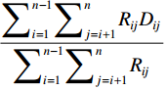 (3.1)

and rel-dist score is given by

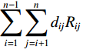 (3.2)

Where

 1 if departments and are on the same floor and adjacent

Dij

0 otherwise

*Rij* is the numeric value assigned to the relationship code between departments i and j

*n* is the total number of departments

*dij* is the rectilinear distance between the centers of departments i and j

Department pairs with a negative numeric value are not included in the summation in the denominator of the adjacency score formula. Instead of printing the rel-dist score directly, BLOCPLAN normalizes the score and prints the resulting value. To do so, it computes a simple lower and upper bound on the value of the rel-dist score by multiplying two vectors—a distance vector whose elements are arranged in nondecreasing order and a relationship code or ﬂow vector whose elements are arranged in nonincreasing order. The first vector includes the distance, whereas the second includes the numeric values corresponding to the relationship code between each pair of departments. Because we are trying to minimize the sum of the product of ﬂow times distance calculated for each pair of departments, it is well known that a lower bound can be obtained by arranging elements of the ﬂow vector in nonincreasing order and the distance vector elements in nondecreasing order. Thus, we are trying to match the largest ﬂow elements with the smallest distance element. Although such a matching may not lead us to the OFV of a feasible solution, it provides us a reasonably tight lower bound to compare the OFV’s of other feasible solutions. Obviously, the optimal solution is the one whose OFV is closest to the lower bound (among all possible feasible solutions). To get an upper bound, we may do the reverse of what we did to compute the lower bound—arrange elements of the two vectors so that the largest ﬂow element is matched with the largest distance element and multiply the two vectors. This means that both the vectors are to be arranged so that their elements are in nondecreasing order. BLOCPLAN thus computes the lower and upper bounds and determines the normalized rel-dist score, called R-score, as [4]

 (3.3)

Thus, an R-score of 1 would mean that the corresponding solution is optimal. Of course, such a value for R-score is highly unlikely because it means that the rel-dist score of the corresponding layout is equal to the lower bound. Similarly, an R-score value of 0 (also highly unlikely) means that the corresponding layout is the worst possible layout because its OFV is equal to the upper bound.

Method of scoring a layout is the "Relationship-Distance" procedure. With this procedure the distance (Rectilinear) between the centroids of each pair of departments is multiplied by the numeric worth of the relationship code for the departments. The sum of all of these values is the "Unnormalized Relationship Distance Score" (URDS) for the layout, where the lower the value the better the layout. With this philosophy, departments that have an "A" relationship will be as close together as possible. Departments with an "X" relationship will be as far apart as possible. BLOCPLAN attempts to normalize this score. For a given layout a vector of all the distances between departments is created. All of the values in this vector are put in ascending order. A vector of the numeric relationship chart values is also created. These are also put into ascending order from the lowest to the highest. A minimum, or lower bound (LB), for the Relationship Distance Score would be the sum of the products with the highest values in the relationship vector multiplied by the lowest values in the distance vector. BLOCPLAN also creates an upper bound (UB) for the layout. This value is found by multiplying the largest code values in the numeric relationship vector by the largest values in the distance vector, and summing the results. This value is called the upper bound (UB) for the layout. The normalized relationship distance score is formula (3.3)

Another scoring procedure that BLOCPLAN presents is simply the total of the material handling activity for the layout. This value is given in Load-Feet, and assumes that the user has given a From/To chart that shows the material handling activity between departments. Again the distance between departments for a layout uses rectilinear distance between department centroids. For any layout that is created by BLOCPLAN, the scores from each of the scoring procedures are reported.

There was a great deal of time spent trying to develop a procedure that would allow BLOCPLAN to create a near optimal layout from just the information provided by the user. It seemed logical to have departments with a large number of positive relationship code values put in the center of the layout, and pairs of departments that have an "X" relationship code placed on opposite corners of the layout. There was still some random placement of departments with the algorithm, so there was some difference in the layouts each time the option was called. However, the option did just not obtain consistently "good" layouts. The procedure that was put in to replace it was the "Automatic Search" algorithm. When this option is selected, BLOCPLAN will place all of the departments into the layout randomly. There are 18 sites where a department can be placed. (AL, AR, BL, …, FL). For a ten department layout, there would be 43,758 possible site selections (Combinations of 18 things taken 10 at atime 18C10). BLOCPLAN will find the adjacency score for the random layout. It will then switch the locations of each pair of departments. For example, suppose Dept 1 is in DR and Dept 2 is in CL. It will place Dept 1 in CL and Dept 2 in DR. It will calculate the adjacency score of this revised layout. If the score is better than the original layout, it will use the revised layout as the starting point and again begin to switch each pair of departments. If there is no improvement for the layout after the switch for departments 1 and 2, it will continue and switch 1 and 3 to see if an improvement can be made. For a 10 department layout, the number of switches that can be made would be 45 [10C2]. Any time an improvement in the score is made, the revised layout will be the used, and the switching process will begin again with the revised layout. The final layout that will be presented will be the one where all 45 switches have been made with no improvement in the score. The centroids and the dimensions for every department in each layout will be presented when it is created.

Each time the "Automatic Search" algorithm is used, the user must specify the number of layouts that are desired. The maximum number is 20. If 20 layouts are specified, the system will start with a random layout for the first one and keep switching department locations until no further improvements can be made. It will then start with a random layout for the second one and repeat the process. After 20 layouts have been created, they will be presented to the user. The adjacency score, the relationship distance score, and the material handling required for each layout is shown. The user can then ask for 20 more layouts to be created. In a short amount of time the user may review several hundred good layouts. We have found it a good idea to keep a record of the "extra good" layouts that are presented. This scorecard record shows the data of layouts that were created and saved by the user. The adjacency, the relationship distance, and the product movement criteria were used for all the layouts that were created.

* 1. **BLOCPLAN development**

In order to make a better understanding about BLOCPLAN algorithm, here is a practical example to develop a layout using BLOCPLAN. Recall the BLOCPLAN flowchart in Figure 1.

**Step 1:**

Give name and Area of Departments as inputs for the BLOCPLAN with maximum number of department is 18. Departments and their area are in the following picture.

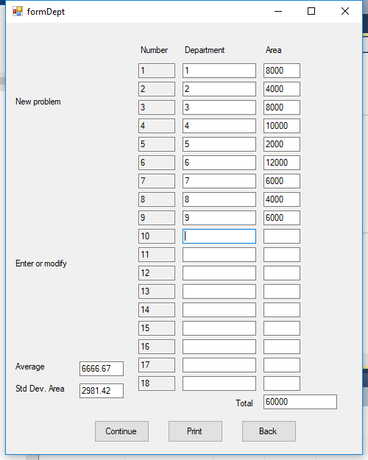

Figure 6 Input department data form

We use Visual Basic for developing the BLOCPLAN. The code is in the appendix. Figure 5 shows department form. This version of BLOCPLAN is able to show the **average and standard deviation** for total area automatically. This **new feature** is important because it can inform the user not to exceed the available area when he is writing down the department data. Input for Area of department should be number, therefore we prevent an input that is not a number.

Variables that we use in this code are:

Public Shared txtNo(18), txtDept(18), txtArea(18), txtAvg, txtDev, txtTotal As TextBox

Private lblNo, lblDept, lblArea, lblTotal, lblEnter, lblAvg, lblDev As Label

Private noPos, deptPos, areaPos, lblTotalPos, totalPos, problemPos, enterPos, avgPos, devPos, continuePos, printPos, backPos As Point

Private btnContinue, btnPrint, btnBack As Button

Where:

1. txtNo(18) = variable to store the number from 1 to 18 in Number column
2. txtDept(18) = variable to store the department name from 1 to 18 in Department column
3. txtArea(18) = variable to store the department area from 1 to 18 in Area column
4. txtAvg = variable to store the average of all input area
5. txtDev = variable to store the standard deviation of all input area
6. txtTotal = variable to store the total area from all departments

**Step 2:**

When a user has inputted the departments info and click continue button, he/she will see the next form of adjacency score input.

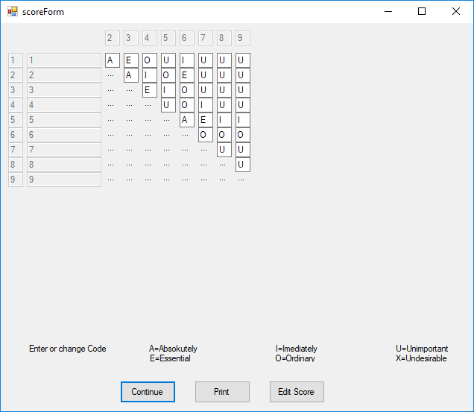

Figure 7 Relationship chart input

For adjacency score input, we prevent improper input so the user can only input letters: A, E, I, O, U which are capital letters. Whenever the user input it in lowercase, the program change it to uppercase automatically.

**Step 3:**

Click edit score button to set the score for each relationship code. User can manually edit the score then save the change. This version provides Restore Default button for getting the score of each code [2].

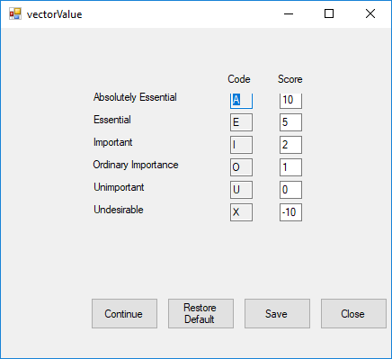

Figure 8 Score for each code

User can obtain the relationship score for each department by clicking continue button of the relationship diagram input. Then, count score button is provided to calculate the score. This **new form** can show which scores contribute to the total value of a department and it helps user knowing the algorithm well because he can trace which number contributes for next calculation, and so on

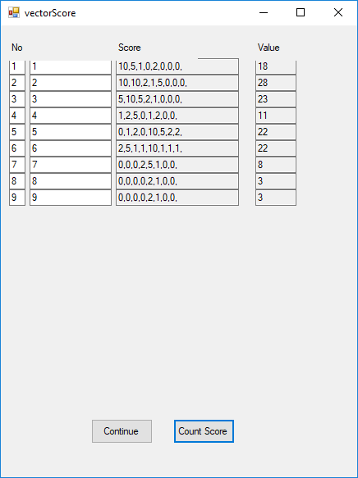

Figure 9 Relationship score calculation for each department

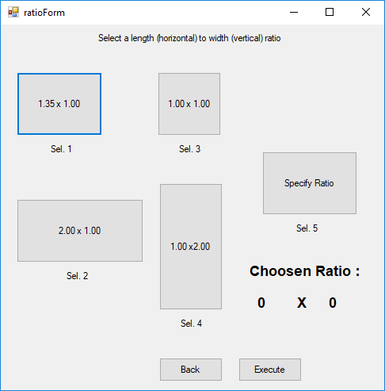

Figure 10 Length width ratio for layout

The available ratio for a layout is given in the figure 9. If user wants another ratio, he can choose Specify Ratio and then input the length and width of the area.

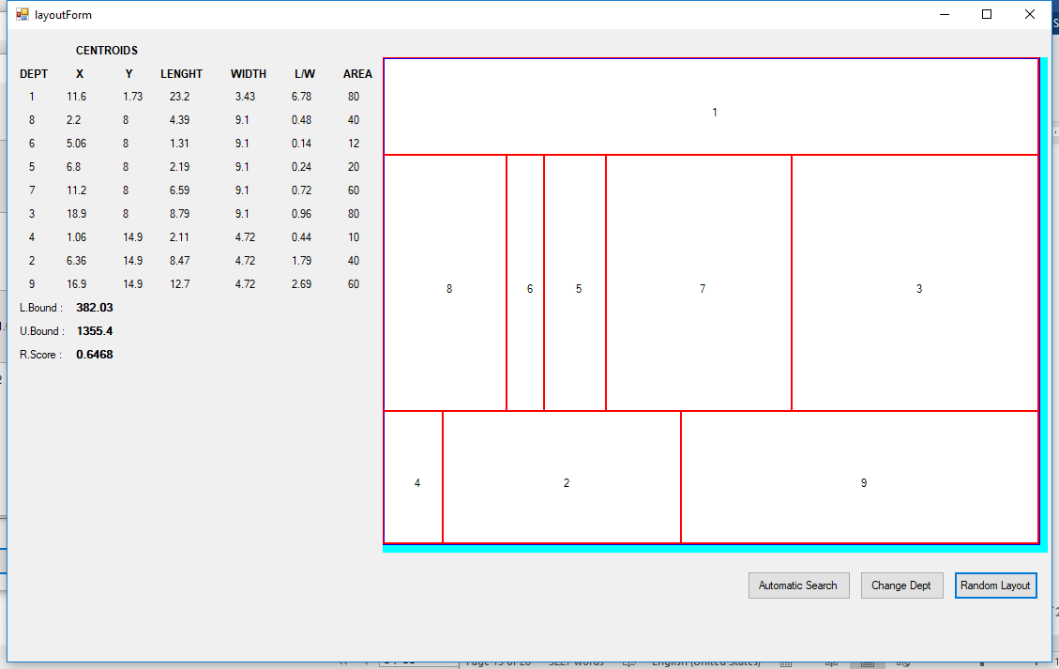

Figure 11 Layout generation with random layout algorithm [4]

Automatic Search with random layout button, user can change the position of department in the layout randomly.

1. **Study Case**

For implementing the new version of BLOCPLAN, we do a small research for getting the appropriate data. We get data from Kustriyanto [10] which studied layout improvement in strategic manufacturing company, ammunition division and we will compare the result from the paper with our result.

* 1. **Problem Statement**

How to improve the existing layout of the company by using BLOCPLAN algorithm.

* 1. **Collecting data**

Existing layout of the department in the company. This department has several production lines with different machine generation/ technology and capacity.

Those machines are grouped based on their process type (Figure 12). The groups are:

* Cell 1 : Drawing I, drawing II, degreasing
* Cell 2 : Drawing I, drawing II, cutting
* Cell 3 : Annealing dan cleaning
* Cell 4 : Indenting, necking, drilling
* Cell 5 : Cleaning, drilling, grooving
* Cell 6 : Gauging
* Cell 7 : Annealing
* Cell 8 : Visual inspection

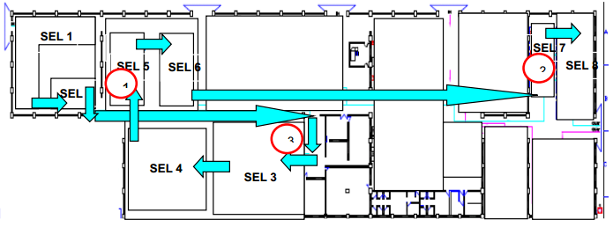

Figure 12 Production line of the company

Data for each cell in the company with its area are in the following table:

Table 4 Area of each machine cell

| No. | Cell | Cell Name | Dimension, (l x w) m | Area m2 | Scale :10 |
| --- | --- | --- | --- | --- | --- |
| 1 | Cell 1 | Drawing | 15,66x9,00 | 140,94 | 14 |
| 2 | Cell 2 | Cutting | 15,66x4,74 | 74,23 | 7.4 |
| 3 | Cell 3 | Annealing and cleaning | 21,63x15,63 | 338,08 | 33.8 |
| 4 | Cell 4 | Indenting, necking, drilling | 16,72x15,63 | 261,33 | 26.1 |
| 5 | Cell 5 | Cleaning, Drilling, grooving | 11.1x11,16 | 123.89 | 12.3 |
| 6 | Cell 6 | Gauging | 15,60x5,58 | 87,06 | 8.7 |
| 7 | Cell 7 | Annealing | 4,89x11,30 | 55,26 | 5.5 |
| 8 | Cell 8 | Visual inspection | 7,65X14,19 | 108,55 | 10.8 |

Relationship between departments is obtained by qualitative assessment. The relationship chart is depicted in the following table:

Table 5 Relationship chart for ammunition division

|  |  |  |  |  |  |  |  |  |
| --- | --- | --- | --- | --- | --- | --- | --- | --- |
| Cell | 1 | 2 | 3 | 4 | 5 | 6 | 7 | 8 |
| 1 |  | A | O | X | X | X | X | X |
| 2 |  |  | A | X | X | X | E | U |
| 3 |  |  |  | A | I | U | X | X |
| 4 |  |  |  |  | A | E | U | U |
| 5 |  |  |  |  |  | A | I | E |
| 6 |  |  |  |  |  |  | A | U |
| 7 |  |  |  |  |  |  |  | A |
| 8 |  |  |  |  |  |  |  |  |

* 1. **Using the new version of BLOCPLAN**

Generating layout using BLOCPLAN needs some data input. We can generate the initial layout and then use automatic search algorithm to get an improvement. The steps are:

**Step 1:**

Input data of department name and the area. BLOCPLAN will automatically calculate the total area, average of the area, and standard deviation (Figure 13)

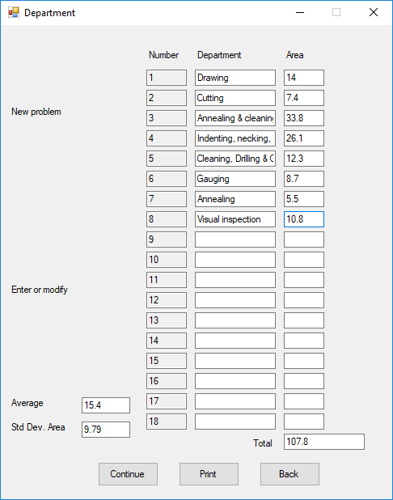

Figure 13 Cell data of the ammunition division

**Step 2:**

Set the Relationship chart based on the data acquired from the paper

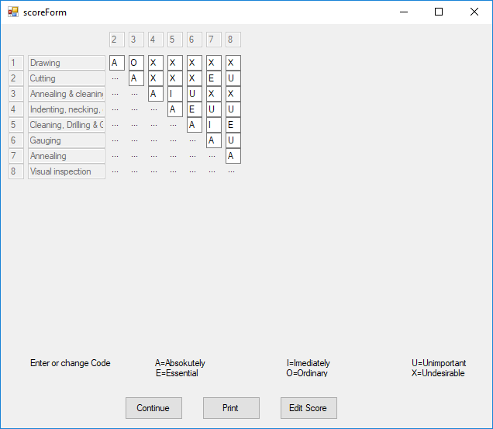

Figure 14 Relationship chart of the company

**Step 3:**

Check the score for each code whether there is a change or just using the default score. In this case study we use the default score provided by Donaghey [2]. Then, we can close the form and click on the continue button on relationship chart window.

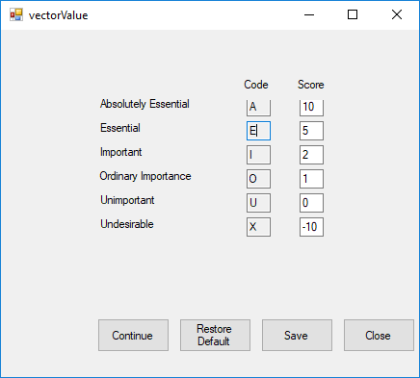

Figure 15 Score for each relationship code

**Step 4:**

We can get the score for each department after we click on the continue button from the relationship chart.

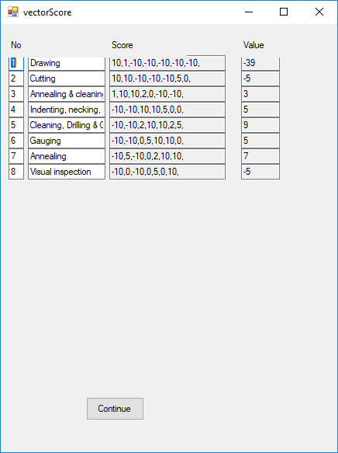

Figure 16 Score for each relationship code

**Step 5:**

From the relationship score, we will select one of the available ratios for the area. We choose the ratio 2.00 x 1.00 (selection 2) for this case, based on the actual data of ammunition department.

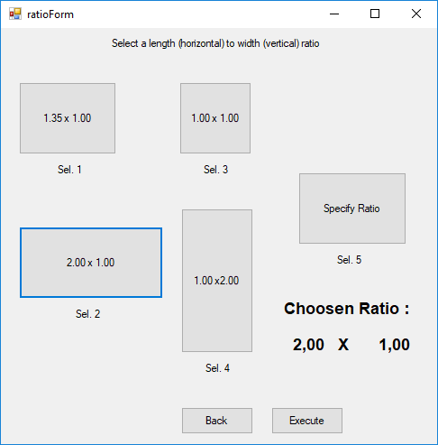

Figure 17 Ratio selection

**Step 6:**

Execute the ratio. The randomized department location in layout will be appeared.

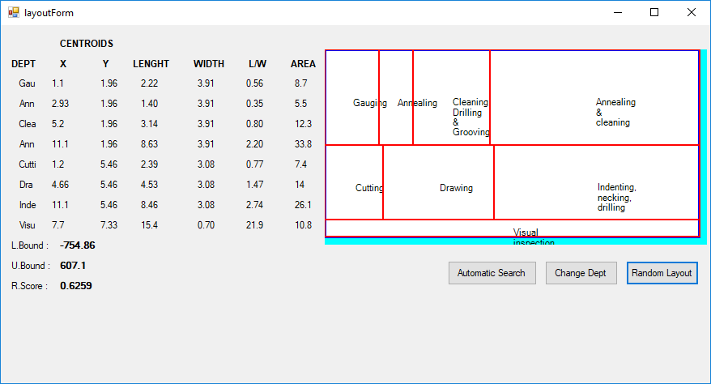

Figure 18 Initial layout from blocplan

BLOCPLAN shows the value of Lower Bound, Upper Bound, and R.Score of the layout. The value is -754.86; 607.1; 0.6259 respectively.

**Step 7:**

Do automatic search algorithm with clicking on the Automatic Search. This button makes a hundred replication of change. Whenever it gets a higher R.Score, it keeps the change and continues the search.

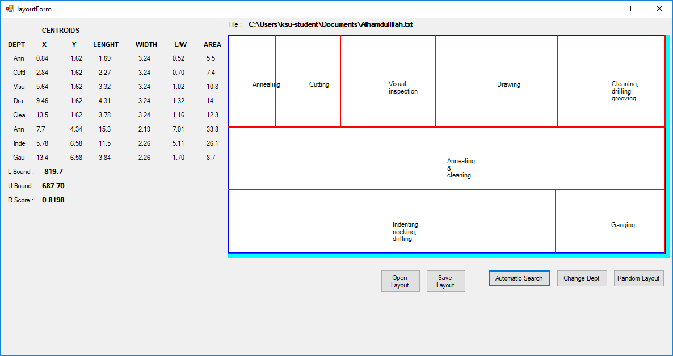

Figure 19 Improved layout

We can see that after the improvement of layout, the R.Score is 0.7989 or there is a **27.6%** improvement from the previous layout.

* 1. **Result comparison**

Result from the paper [10] for R.Score is compared with the R.Score from the new version of BLOCPLAN. The alternative layout from the paper are:

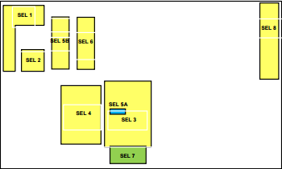

Figure 20 Alternative layout 1 from paper

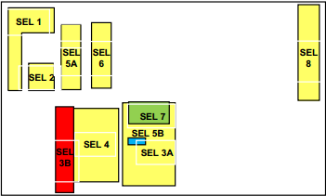

Figure 21 Alternative layout 2 from paper

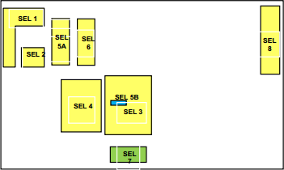

Figure 22 Alternative layout 3 from paper

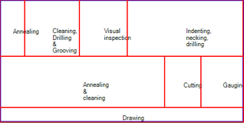

Figure 23 Improved layout from new blocplan

The R.Score for each layout:

Table 6 R.Score comparison

|  |  |  |
| --- | --- | --- |
| No. | Alternative Layout | R.Score |
| 1 | Alternative 1 | 0.67 |
| 2 | Alternative 2 | 0.67 |
| 3 | Alternative 3 | 0.33 |
| 4 | Blocplan | 0.82 |

Table 6 shows us the R.Score of each alternative layout. The R.Score has the nature, bigger number means better. It is obvious that the bigger value is for the new version of Blocplan.

* 1. **Discussion**

Result from the paper has a relative smaller value than the result from new version of Blocplan. This is because:

1. Methodology of paper for improvement is placing the cell to a certain location and then calculate the R.Score with Blocplan
2. Blocplan ability of automatically searching a higher value of R.Score is not applied.
3. **Conclusion**

* Blocplan is able to deal with the location size of workplace and keep it rectangular
* Several features that user need are available in this version of Blocplan such as: information about total area when department data form is on, average and standard deviation and department change one by one with pairwise exchange
* Result of the new version of blocplan is better than result of the paper due to the difference in method for applying the Blocplan

1. **References**

[1] Badiru, Adedeji B. & Alaa Arif (2007). FLEXPERT: facility layout expert system using fuzzy linguistic relationship codes. IIE Transactions Volume 28, 1996 - Issue 4. Abstract from: https://www.tandfonline.com/doi/abs/10.1080/07408179608966277 (accessed: April 25th 2018)

[2] Donaghey, Charles E., Christopher A. Chung & Hayian Kong (2007). Blocplan For Windows: Computer Aided Facility Layout Methodology And Enhancements. Proceedings of the 2007 Industrial Engineering Research Conference.

[3] Goetschalckx, M (1992). An interactive layout heuristic based on hexagonal adjacency graphs. European Journal of Operational Research 63. 304-321

[4] Heragu, Sunderesh S. (2016). Facility Design p. 124-125. CRC Press.

[5] Leonardo, Hutahaean, H.A., & Wee, Hui-Ming (2014). Comparing alternative plant layouts based on Craft and Blocplan algorithms. Metris Journal Vol. 15. 55–64

[6] M Tambunan, et al. (2018). Production facility layout by comparing moment displacement using BLOCPLAN and ALDEP Algorithms. IOP Conference Series: Materials Science and Engineering 309 012032.

[7] Puspita, I.A., et al. (2015). Production facility layout design using blocplan algorithm. American Scientific Publishers.

[8] Ahmadi, A., Pishvaee, M. S., Jokar, M. R. A. (2017). A survey on multi-floor facility layout problems Computers & Industrial Engineering 107 (2017) 158–170.

[9] Universidad ICESI. Facility Layout 5. Powerpoint material from ftp://200.3.193.30/leonardo/DistPlanta/Slides/Layout-5-05166.ppt (accessed March 9th 2018)

[10] Kustriyanto, E., Pambuditama, I., Irawan, Y.S.(2016). Layout improvement of ammunition sleeves production machine with systematic layout planning method and blocplan. Mechanical Engineering Journal Vol.7, No.3 Year 2016: 103-112.

**APPENDIX**

* Code for Figure 5

Me.Size = New Size(500, 625) : Me.CenterToScreen()

noPos = New Point(180, 30)

Dim lblNo As New Label With {.Text = "Number", .Location = noPos, .Width = 50}

deptPos = New Point(noPos.X + lblNo.Width + 10, noPos.Y)

Dim lblDept As New Label With {.Text = "Department", .Location = New Point(deptPos)}

areaPos = New Point(deptPos.X + lblDept.Width + 10, noPos.Y)

Dim lblArea As New Label With {.Text = "Area", .Location = New Point(areaPos), .Width = 50}

Me.Controls.Add(lblNo) : Me.Controls.Add(lblDept) : Me.Controls.Add(lblArea)

Dim i As Integer

For i = 1 To 18 'Create a new textbox and set its properties26.27.

txtNo(i) = New TextBox : txtDept(i) = New TextBox : txtArea(i) = New TextBox

txtNo(i).Size = New Drawing.Size(50, 20) : txtDept(i).Size = New Drawing.Size(100, 20) : txtArea(i).Size = txtNo(i).Size

txtNo(i).Location = New Point(noPos.X, noPos.Y + 25 * (i)) : txtNo(i).Text = i.ToString : txtNo(i).ReadOnly = True

txtDept(i).Location = New Point(deptPos.X, deptPos.Y + 25 * (i)) : txtDept(i).Name = "dept" & i

txtArea(i).Location = New Point(areaPos.X, areaPos.Y + 25 * (i)) : txtArea(i).Name = i

Me.Controls.Add(txtNo(i)) : Me.Controls.Add(txtDept(i)) : Me.Controls.Add(txtArea(i))

AddHandler txtArea(i).KeyPress, AddressOf area_keypressed

AddHandler txtArea(i).Leave, AddressOf area_textchanged

Next

'MessageBox.Show(deptPos.Y + 25 * i)

lblTotalPos = New Point(deptPos.X, deptPos.Y + 25 * i) : totalPos = New Point(areaPos.X, areaPos.Y + 25 * i)

Dim lblTotal As New Label With {.Text = "Total", .Location = lblTotalPos, .Width = 100, .TextAlign = ContentAlignment.MiddleRight}

txtTotal = New TextBox() With {.Location = totalPos, .Width = 100, .Text = ""}

Me.Controls.Add(lblTotal) : Me.Controls.Add(txtTotal)

' For object out of input department

problemPos = New Point(10, 100)

Dim lblProblem As New Label With {.Text = "New problem", .Location = problemPos}

enterPos = New Point(problemPos.X, problemPos.Y + 220)

Dim lblEnter As New Label With {.Text = "Enter or modify problem data", .Location = enterPos}

avgPos = New Point(problemPos.X, problemPos.Y + 360)

Dim lblAvg As New Label With {.Text = "Average", .Location = avgPos, .Width = 80}

txtAvg = New TextBox() With {.Location = New Point(avgPos.X + 90, avgPos.Y), .Width = 60, .Height = 20}

devPos = New Point(problemPos.X, problemPos.Y + 390)

Dim lblDev As New Label With {.Text = "Std Dev. Area", .Location = devPos, .Width = 80}

txtDev = New TextBox() With {.Location = New Point(devPos.X + 90, devPos.Y), .Width = 60, .Height = 20}

Dim btnContinue As New Button With {.Location = New Point(devPos.X + 110, devPos.Y + 50), .Width = 75, .Height = 30, .Text = "Continue"}

Dim btnPrint As New Button With {.Location = New Point(devPos.X + 210, devPos.Y + 50), .Width = 75, .Height = 30, .Text = "Print"}

Dim btnBack As New Button With {.Location = New Point(devPos.X + 310, devPos.Y + 50), .Width = 75, .Height = 30, .Text = "Back"}

AddHandler btnContinue.Click, AddressOf continue_click

Me.Controls.Add(lblProblem) : Me.Controls.Add(lblEnter) : Me.Controls.Add(lblEnter) : Me.Controls.Add(lblAvg) : Me.Controls.Add(txtAvg)

Me.Controls.Add(lblDev) : Me.Controls.Add(txtDev) : Me.Controls.Add(btnContinue) : Me.Controls.Add(btnPrint) : Me.Controls.Add(btnBack)

End Sub

* Input for Area of department should be number, therefore we prevent an input that is not a number. Code for preventing non-numerical input is:

Private Sub area_keypressed(ByVal sender As Object, ByVal e As System.Windows.Forms.KeyPressEventArgs)

If e.KeyChar <> ControlChars.Back Then

Dim allowedChars As String = "0123456789.,"

If allowedChars.IndexOf(e.KeyChar) = -1 Then

' Invalid Character

e.Handled = True

End If

End If

End Sub

* In this form, we provide the total area of departments, average and standard deviation of them. The code for calculation is:

Private Sub area_textchanged(ByVal sender As Object, ByVal e As EventArgs)

Dim area As TextBox = sender

If txtDept(area.Name).Text = "" Then

MessageBox.Show("Department Name must be filled")

txtDept(area.Name).Focus()

End If

Dim total, totalSquare, stddev As Double : total = 0 : totalSquare = 0

Dim count As Integer : count = 0

For i As Integer = 1 To 18

If txtArea(i).Text = "" Then

Else

total += CDbl(txtArea(i).Text)

totalSquare += CDbl(txtArea(i).Text) ^ 2

count += 1

End If

Next

stddev = Math.Sqrt((totalSquare - (total * total / count)) / count)

txtTotal.Text = Math.Round(total, 2)

txtAvg.Text = Math.Round(total / count, 2)

txtDev.Text = Math.Round(stddev, 2)

End Sub

* When a user has inputted the departments info and click continue button, he/she will see next form of adjacency score input. The code for Figure 6 is:

Private Sub continue_click(ByVal sender As Object, ByVal e As EventArgs)

scoreForm.Show()

End Sub

The code for adjacency form is:

Me.Size = New Size(650, 560)

Dim firstHorizPoint As Point = New Point(firstPoint.X + 130, firstPoint.Y - 10)

For k As Integer = 2 To count

textNoH(k) = New TextBox() With {.Location = New Point(firstHorizPoint.X + (k - 2) * 25, firstHorizPoint.Y), .Width = 20, .Text = k, .ReadOnly = True}

Me.Controls.Add(textNoH(k))

Next

For i As Integer = 1 To count

textNoV(i) = New TextBox() With {.Location = New Point(firstPoint.X, firstPoint.Y + i * 20), .Width = 20, .Text = i}

textDept(i) = New TextBox() With {.Location = New Point(firstPoint.X + 25, firstPoint.Y + i * 20), .Width = 100, .Text = formDept.txtDept(i).Text}

Me.Controls.Add(textNoV(i)) : Me.Controls.Add(textDept(i))

For j As Integer = 2 To count

textVal(i, j) = New TextBox() With {.Location = New Point(firstPoint.X + 130 + (j - 2) * 25, firstHorizPoint.Y + 10 + i * 20), .Width = 20, .MaxLength = 1, .CharacterCasing = CharacterCasing.Upper}

blk = New Label With {.Location = New Point(firstPoint.X + 130 + (j - 2) * 25, firstHorizPoint.Y + 10 + i * 20), .Width = 20, .Text = "..."}

If i >= j Then

Me.Controls.Add(blk)

Else

Me.Controls.Add(textVal(i, j))

AddHandler textVal(i, j).KeyPress, AddressOf scoreVal_value

End If

Next

Next

enterCode = New Label() With {.Location = New Point(firstPoint.X + 25, firstPoint.Y + 410), .Width = 1000, .Height = 25, _

.Text = "Enter or change Code" & Space(19) & "A=Absokutely" & Space(35) & "I=Imediately" & Space(35) & _

"U=Unimportant" & Chr(13) & Space(54) & "E=Essential" & Space(38) & "O=Ordinary" & Space(36) & "X=Undesirable"}

Dim btnContinue As New Button With {.Location = New Point(firstPoint.X + 250, firstPoint.Y + 460), .Width = 75, .Height = 30, .Text = "Continue"}

AddHandler btnContinue.Click, AddressOf continue_click

Dim btnPrint As New Button With {.Location = New Point(firstPoint.X + 350, firstPoint.Y + 460), .Width = 75, .Height = 30, .Text = "Print"}

Me.Controls.Add(enterCode) : Me.Controls.Add(btnContinue) : Me.Controls.Add(btnPrint)

End Sub

Private Sub continue_click(ByVal sender As Object, ByVal e As EventArgs)

'vectorValueForm.Show()

End Sub

Private Sub scoreVal_value(ByVal sender As Object, ByVal e As KeyPressEventArgs)

If e.KeyChar <> ControlChars.Back Then

Dim allowedChars As String = "aiueoxAIUEOX"

If allowedChars.IndexOf(e.KeyChar) = -1 Then

e.Handled = True

End If

End If

End Sub

* For adjacency score input, we prevent improper input so the user can only input letters: A, E, I, O, U which are capital letters. Whenever the user input it in lowercase, the program change it to uppercase automatically with this code:

If e.KeyChar <> ControlChars.Back Then

Dim allowedChars As String = "aiueoxAIUEOX"

If allowedChars.IndexOf(e.KeyChar) = -1 Then

e.Handled = True

End If

End If

For j As Integer = 2 To count

textVal(i, j) = New TextBox() With {.Location = New Point(firstPoint.X + 130 + (j - 2) * 25, firstHorizPoint.Y + 10 + i * 20), .Width = 20, .MaxLength = 1, .CharacterCasing = CharacterCasing.Upper}

blk = New Label With {.Location = New Point(firstPoint.X + 130 + (j - 2) * 25, firstHorizPoint.Y + 10 + i * 20), .Width = 20, .Text = "..."}

If i >= j Then

Me.Controls.Add(blk)

Else

Me.Controls.Add(textVal(i, j))

End If

* If we click edit score button, the score of each relationship codes are appeared. The code for Figure 7 is:

Public Class vectorValueForm

Private scoreA, scoreE, scoreI, scoreO, scoreU, scoreX As TextBox

Private Sub Form1_Load(sender As Object, e As EventArgs) Handles MyBase.Load

Dim firstPos As Point = New Point(100, 50)

Dim lblCode, lblAbs, lblEss, lblImp, lblOrd, lblUnim, lblUndes As Label

Dim codeA, codeE, codeI, codeO, codeU, codeX As TextBox

lblCode = New Label With {.Location = New Point(firstPos.X + 150, firstPos.Y), .Width = 200, .Text = "Code" & Space(10) & "Score"}

lblAbs = New Label With {.Location = New Point(firstPos.X, firstPos.Y + 20), .Width = 150, .Text = "Absolutely Essential"}

lblEss = New Label With {.Location = New Point(firstPos.X, firstPos.Y + 45), .Width = 150, .Text = "Essential"}

lblImp = New Label With {.Location = New Point(firstPos.X, firstPos.Y + 70), .Width = 150, .Text = "Important"}

lblOrd = New Label With {.Location = New Point(firstPos.X, firstPos.Y + 95), .Width = 150, .Text = "Ordinary Importance"}

lblUnim = New Label With {.Location = New Point(firstPos.X, firstPos.Y + 120), .Width = 150, .Text = "Unimportant"}

lblUndes = New Label With {.Location = New Point(firstPos.X, firstPos.Y + 145), .Width = 150, .Text = "Undesirable"}

Me.Controls.Add(lblCode) : Me.Controls.Add(lblAbs) : Me.Controls.Add(lblEss) : Me.Controls.Add(lblImp)

Me.Controls.Add(lblOrd) : Me.Controls.Add(lblUnim) : Me.Controls.Add(lblUndes)

codeA = New TextBox With {.Location = New Point(firstPos.X + 155, firstPos.Y + 20), .Width = 25, .Text = "A", .ReadOnly = True}

codeE = New TextBox With {.Location = New Point(firstPos.X + 155, firstPos.Y + 45), .Width = 25, .Text = "E", .ReadOnly = True}

codeI = New TextBox With {.Location = New Point(firstPos.X + 155, firstPos.Y + 70), .Width = 25, .Text = "I", .ReadOnly = True}

codeO = New TextBox With {.Location = New Point(firstPos.X + 155, firstPos.Y + 95), .Width = 25, .Text = "O", .ReadOnly = True}

codeU = New TextBox With {.Location = New Point(firstPos.X + 155, firstPos.Y + 120), .Width = 25, .Text = "U", .ReadOnly = True}

codeX = New TextBox With {.Location = New Point(firstPos.X + 155, firstPos.Y + 145), .Width = 25, .Text = "X", .ReadOnly = True}

Me.Controls.Add(codeA) : Me.Controls.Add(codeE) : Me.Controls.Add(codeI) : Me.Controls.Add(codeO) : Me.Controls.Add(codeU) : Me.Controls.Add(codeX)

scoreA = New TextBox With {.Location = New Point(firstPos.X + 210, firstPos.Y + 20), .Width = 25, .Text = "10"}

scoreE = New TextBox With {.Location = New Point(firstPos.X + 210, firstPos.Y + 45), .Width = 25, .Text = "5"}

scoreI = New TextBox With {.Location = New Point(firstPos.X + 210, firstPos.Y + 70), .Width = 25, .Text = "2"}

scoreO = New TextBox With {.Location = New Point(firstPos.X + 210, firstPos.Y + 95), .Width = 25, .Text = "1"}

scoreU = New TextBox With {.Location = New Point(firstPos.X + 210, firstPos.Y + 120), .Width = 25, .Text = "0"}

scoreX = New TextBox With {.Location = New Point(firstPos.X + 210, firstPos.Y + 145), .Width = 25, .Text = "-10"}

Me.Controls.Add(scoreA) : Me.Controls.Add(scoreE) : Me.Controls.Add(scoreI) : Me.Controls.Add(scoreO) : Me.Controls.Add(scoreU) : Me.Controls.Add(scoreX)

Dim btnContinue As New Button With {.Location = New Point(firstPos.X + 30, firstPos.Y + 250), .Width = 75, .Height = 35, .Text = "Continue"}

Dim btnRestore As New Button With {.Location = New Point(firstPos.X + 130, firstPos.Y + 250), .Width = 75, .Height = 35, .Text = "Restore Default"}

Dim btnPrint As New Button With {.Location = New Point(firstPos.X + 230, firstPos.Y + 250), .Width = 75, .Height = 35, .Text = "Print"}

AddHandler btnRestore.Click, AddressOf restore_default

Me.Controls.Add(btnContinue) : Me.Controls.Add(btnRestore) : Me.Controls.Add(btnPrint)

End Sub

Private Sub restore_default(sender As Object, e As EventArgs)

scoreA.Text = "10"

scoreE.Text = "5"

scoreI.Text = "2"

scoreO.Text = "1"

scoreU.Text = "0"

scoreX.Text = "-10"

End Sub

End Class

* User can edit the value of each relationship code. The code is:

Public Class vectorValue

Shared firstPos As Point = New Point(100, 50)

Dim WithEvents txtscoreA, txtscoreE, txtscoreI, txtscoreO, txtscoreU, txtscoreX As TextBox

Dim WithEvents btnContinue, btnRestore, btnSave, btnClose As Button

Private Sub vectorValue_Load(sender As Object, e As EventArgs) Handles MyBase.Load

Me.Size = New Size(450, 400)

Dim lblCode, lblAbs, lblEss, lblImp, lblOrd, lblUnim, lblUndes As Label

Dim codeA, codeE, codeI, codeO, codeU, codeX As TextBox

lblCode = New Label With {.Location = New Point(firstPos.X + 150, firstPos.Y), .Width = 200, .Text = "Code" & Space(10) & "Score"}

lblAbs = New Label With {.Location = New Point(firstPos.X, firstPos.Y + 20), .Width = 150, .Text = "Absolutely Essential"}

lblEss = New Label With {.Location = New Point(firstPos.X, firstPos.Y + 45), .Width = 150, .Text = "Essential"}

lblImp = New Label With {.Location = New Point(firstPos.X, firstPos.Y + 70), .Width = 150, .Text = "Important"}

lblOrd = New Label With {.Location = New Point(firstPos.X, firstPos.Y + 95), .Width = 150, .Text = "Ordinary Importance"}

lblUnim = New Label With {.Location = New Point(firstPos.X, firstPos.Y + 120), .Width = 150, .Text = "Unimportant"}

lblUndes = New Label With {.Location = New Point(firstPos.X, firstPos.Y + 145), .Width = 150, .Text = "Undesirable"}

Me.Controls.Add(lblCode) : Me.Controls.Add(lblAbs) : Me.Controls.Add(lblEss) : Me.Controls.Add(lblImp)

Me.Controls.Add(lblOrd) : Me.Controls.Add(lblUnim) : Me.Controls.Add(lblUndes)

codeA = New TextBox With {.Location = New Point(firstPos.X + 155, firstPos.Y + 20), .Width = 25, .Text = "A", .ReadOnly = True}

codeE = New TextBox With {.Location = New Point(firstPos.X + 155, firstPos.Y + 45), .Width = 25, .Text = "E", .ReadOnly = True}

codeI = New TextBox With {.Location = New Point(firstPos.X + 155, firstPos.Y + 70), .Width = 25, .Text = "I", .ReadOnly = True}

codeO = New TextBox With {.Location = New Point(firstPos.X + 155, firstPos.Y + 95), .Width = 25, .Text = "O", .ReadOnly = True}

codeU = New TextBox With {.Location = New Point(firstPos.X + 155, firstPos.Y + 120), .Width = 25, .Text = "U", .ReadOnly = True}

codeX = New TextBox With {.Location = New Point(firstPos.X + 155, firstPos.Y + 145), .Width = 25, .Text = "X", .ReadOnly = True}

Me.Controls.Add(codeA) : Me.Controls.Add(codeE) : Me.Controls.Add(codeI) : Me.Controls.Add(codeO) : Me.Controls.Add(codeU) : Me.Controls.Add(codeX)

txtscoreA = New TextBox With {.Location = New Point(firstPos.X + 210, firstPos.Y + 20), .Width = 25, .Text = scoreForm.scoreA, .Name = "A"}

txtscoreE = New TextBox With {.Location = New Point(firstPos.X + 210, firstPos.Y + 45), .Width = 25, .Text = scoreForm.scoreE, .Name = "E"}

txtscoreI = New TextBox With {.Location = New Point(firstPos.X + 210, firstPos.Y + 70), .Width = 25, .Text = scoreForm.scoreI, .Name = "I"}

txtscoreO = New TextBox With {.Location = New Point(firstPos.X + 210, firstPos.Y + 95), .Width = 25, .Text = scoreForm.scoreO, .Name = "O"}

txtscoreU = New TextBox With {.Location = New Point(firstPos.X + 210, firstPos.Y + 120), .Width = 25, .Text = scoreForm.scoreU, .Name = "U"}

txtscoreX = New TextBox With {.Location = New Point(firstPos.X + 210, firstPos.Y + 145), .Width = 25, .Text = scoreForm.scoreX, .Name = "X"}

Me.Controls.Add(txtscoreA) : Me.Controls.Add(txtscoreE) : Me.Controls.Add(txtscoreI) : Me.Controls.Add(txtscoreO) : Me.Controls.Add(txtscoreU) : Me.Controls.Add(txtscoreX)

Dim btnContinue As New Button With {.Location = New Point(firstPos.X, firstPos.Y + 250), .Width = 75, .Height = 35, .Text = "Continue"}

Dim btnRestore As New Button With {.Location = New Point(firstPos.X + 85, firstPos.Y + 250), .Width = 75, .Height = 35, .Text = "Restore Default"}

Dim btnSave As New Button With {.Location = New Point(firstPos.X + 170, firstPos.Y + 250), .Width = 75, .Height = 35, .Text = "Save"}

AddHandler btnSave.Click, AddressOf save_score

Dim btnClose As New Button With {.Location = New Point(firstPos.X + 255, firstPos.Y + 250), .Width = 75, .Height = 35, .Text = "Close"}

AddHandler btnClose.Click, AddressOf close_form

AddHandler btnRestore.Click, AddressOf restore_default

Me.Controls.Add(btnContinue) : Me.Controls.Add(btnRestore) : Me.Controls.Add(btnSave) : Me.Controls.Add(btnClose)

End Sub

Private Sub restore_default(sender As Object, e As EventArgs)

txtscoreA.Text = "10"

txtscoreE.Text = "5"

txtscoreI.Text = "2"

txtscoreO.Text = "1"

txtscoreU.Text = "0"

txtscoreX.Text = "-10"

End Sub

Sub save_score(sender As Object, e As EventArgs) Handles btnSave.Click

For i = 1 To scoreForm.count

For j = 2 To scoreForm.count

If i >= j Then

'nothing

Else

Select Case scoreForm.textVal(i, j).Text

Case "A"

scoreForm.scoreVal(i, j) = CInt(txtscoreA.Text)

Case "E"

scoreForm.scoreVal(i, j) = CInt(txtscoreE.Text)

Case "I"

scoreForm.scoreVal(i, j) = CInt(txtscoreI.Text)

Case "O"

scoreForm.scoreVal(i, j) = CInt(txtscoreO.Text)

Case "U"

scoreForm.scoreVal(i, j) = CInt(txtscoreU.Text)

Case "X"

scoreForm.scoreVal(i, j) = CInt(txtscoreX.Text)

End Select

End If

Next

Next

scoreForm.scoreA = CInt(txtscoreA.Text)

scoreForm.scoreE = CInt(txtscoreE.Text)

scoreForm.scoreI = CInt(txtscoreI.Text)

scoreForm.scoreO = CInt(txtscoreO.Text)

scoreForm.scoreU = CInt(txtscoreU.Text)

scoreForm.scoreX = CInt(txtscoreX.Text)

MessageBox.Show("Score has been saved")

End Sub

Sub close_form(sender As Object, e As EventArgs) Handles btnClose.Click

Me.Close()

End Sub

End Class

* Another new feature in this version of BLOCPLAN is its ability to show each value of relationship score, as shown in Figure 8. The code for Figure 8 is:

Public Class vectorScore

Dim firstPoint As New Point(10, 20)

Dim lblNo, lblDept, lblScore, lblTot As Label

Dim textNo(18), textDept(18), textVal(18, 18), score(18), totVal(18) As TextBox

'Private scoreVal(18, 18) As Integer

Private thisCount As Integer = scoreForm.count

Shared column, row As Integer

Private Sub scoreForm_Load(sender As Object, e As EventArgs) Handles MyBase.Load

Me.Size = New Size(450, 590)

lblNo = New Label() With {.Location = New Point(firstPoint.X, firstPoint.Y), .Text = "No"}

lblDept = New Label() With {.Location = New Point(firstPoint.X + 25, firstPoint.Y), .Text = "Department"}

lblScore = New Label() With {.Location = New Point(firstPoint.X + 130, firstPoint.Y), .Text = "Score"}

lblTot = New Label() With {.Location = New Point(firstPoint.X + 300, firstPoint.Y), .Text = "Value"}

Me.Controls.Add(lblNo) : Me.Controls.Add(lblDept) : Me.Controls.Add(lblScore) : Me.Controls.Add(lblTot)

For n = 1 To thisCount

textNo(n) = New TextBox() With {.Location = New Point(firstPoint.X, firstPoint.Y + n * 20), .Width = 20, .Text = n}

textDept(n) = New TextBox() With {.Location = New Point(firstPoint.X + 25, firstPoint.Y + n * 20), .Width = 100, .Text = formDept.txtDept(n).Text}

score(n) = New TextBox() With {.Location = New Point(firstPoint.X + 130, firstPoint.Y + n * 20), .Width = 150, .ReadOnly = True}

totVal(n) = New TextBox() With {.Location = New Point(firstPoint.X + 300, firstPoint.Y + n * 20), .Width = 50, .ReadOnly = True, .Text = 0}

Me.Controls.Add(textNo(n)) : Me.Controls.Add(textDept(n))

Me.Controls.Add(score(n)) : Me.Controls.Add(totVal(n))

Next

Dim firstHorizPoint As Point = New Point(firstPoint.X + 130, firstPoint.Y - 10)

Dim btnContinue As New Button With {.Location = New Point(firstPoint.X + 100, firstPoint.Y + 460), .Width = 75, .Height = 30, .Text = "Continue"}

'Dim btnCount As New Button With {.Location = New Point(firstPoint.X + 200, firstPoint.Y + 460), .Width = 75, .Height = 30, .Text = "Count Score"}

AddHandler btnContinue.Click, AddressOf ratio_form

Me.Controls.Add(btnContinue) 'Me.Controls.Add(btnCount) 'Me.Controls.Add(enterCode)

count_click()

End Sub

Private Sub textVal_value(sender As Object, e As KeyPressEventArgs)

If e.KeyChar <> ControlChars.Back Then

Dim allowedChars As String = "aiueoxAIUEOX"

If allowedChars.IndexOf(e.KeyChar) = -1 Then

e.Handled = True

End If

End If

End Sub

Private Sub count_click()

'Clearing the score and total value before counting

For i = 1 To thisCount

score(i).Text = ""

totVal(i).Text = "0"

Next

'thisCount score Value for Columns

Dim n As Integer

For i = 1 To thisCount

For j = 2 To thisCount

If i >= j Then

'nothing

Else

For k = i To j

If i = k Then

score(j).Text += scoreForm.scoreVal(i, j) & ","

n = Convert.ToInt32(totVal(j).Text)

n += scoreForm.scoreVal(i, j)

totVal(j).Text = n

End If

Next

End If

Next

Next

'Count score Value for Rows

For j = 2 To thisCount

For i = 1 To thisCount

If i >= j Then

'nothing

Else

For k = i To j - 1

If i = k Then

score(i).Text += scoreForm.scoreVal(i, j) & ","

n = Convert.ToInt32(totVal(i).Text)

n += scoreForm.scoreVal(i, j)

totVal(i).Text = n

End If

Next

End If

Next

Next

End Sub

Private Sub ratio_form(sender As Object, e As EventArgs)

ratioForm.Show()

End Sub

End Class

* Area of which departments will be placed has a certain width and length. From BLOCPLAN DOS version, we find there are four selectable ratios for the area. However, user can input his own ratio with Specify Ratio selection. This feature is shown in Figure 9 and following is its code:

Public Class ratioForm

Private firstPos As Point = New Point(20, 10)

Private WithEvents btn135_1, btn1_1, btn2_1, btn1_2, btnSpy, btnBack, btnExe As Button

Private lblSel1, lblSel2, lblSel3, lblSel4, lblSel5, lblChoosen, lblRatioY, lblRatioX, lblX As Label

Public Shared ratioX, ratioY As String

Private calib As Integer = 80

Private Sub ratioForm_Load(sender As Object, e As EventArgs) Handles MyBase.Load

Me.Size = New Size(500, 500) : ratioX = 0.0 : ratioY = 0.0

Dim lblTitle As Label = New Label() With {.Location = New Point(firstPos.X + 100, firstPos.Y), .Width = 300, .Text = "Select a length (horizontal) to width (vertical) ratio"}

Dim lblSel1 As Label = New Label() With {.Location = New Point(firstPos.X + (1 * calib) / 2, firstPos.Y + 1 * calib + 60), .Width = 50, .Text = "Sel. 1", .Name = "oke"}

Dim lblSel2 As Label = New Label() With {.Location = New Point(firstPos.X + (1.5 * calib) / 2, firstPos.Y + 2 * calib + 140), .Width = 50, .Text = "Sel. 2"}

Dim lblSel3 As Label = New Label() With {.Location = New Point(firstPos.X + calib * 1.35 + 70 + (0.6 * calib) / 2, firstPos.Y + 1 * calib + 60), .Width = 50, .Text = "Sel. 3"}

Dim lblSel4 As Label = New Label() With {.Location = New Point(firstPos.X + 2 * calib + 20 + (0.6 * calib) / 2, firstPos.Y + 3 * calib + 120), .Width = 50, .Text = "Sel. 4"}

Dim lblSel5 As Label = New Label() With {.Location = New Point(firstPos.X + 3 * calib + 70 + (1 * calib) / 2, firstPos.Y + 2 * calib + 80), .Width = 50, .Text = "Sel. 5"}

Me.Controls.Add(lblTitle) : Me.Controls.Add(lblSel1) : Me.Controls.Add(lblSel2) : Me.Controls.Add(lblSel3) : Me.Controls.Add(lblSel4) : Me.Controls.Add(lblSel5)

btn135_1 = New Button() With {.Location = New Point(firstPos.X, firstPos.Y + 50), .Size = New Size(1.35 * calib, 1 * calib), .Text = "1.35 x 1.00"}

btn1_1 = New Button() With {.Location = New Point(firstPos.X + calib * 1.35 + 70, firstPos.Y + 50), .Size = New Size(1 * calib, 1 * calib), .Text = "1.00 x 1.00"}

btn2_1 = New Button() With {.Location = New Point(firstPos.X, firstPos.Y + 1 * calib + 130), .Size = New Size(2 * calib, 1 * calib), .Text = "2.00 x 1.00"}

btn1_2 = New Button() With {.Location = New Point(firstPos.X + 2 * calib + 20, firstPos.Y + 1 * calib + 110), .Size = New Size(1 * calib, 2 * calib), .Text = "1.00 x2.00"}

btnSpy = New Button() With {.Location = New Point(firstPos.X + 3 * calib + 70, firstPos.Y + 1 * calib + 70), .Size = New Size(1.5 * calib, 1 * calib), .Text = "Specify Ratio"}

btnBack = New Button() With {.Location = New Point(firstPos.X + 2 * calib + 20, firstPos.Y + 3 * calib + 170), .Size = New Size(1 * calib, 30), .Text = "Back"}

btnExe = New Button() With {.Location = New Point(firstPos.X + 2 * calib + 120, firstPos.Y + 3 * calib + 170), .Size = New Size(1 * calib, 30), .Text = "Execute"}

AddHandler btn1_1.Click, AddressOf btn_click

Me.Controls.Add(btn135_1) : Me.Controls.Add(btn1_1) : Me.Controls.Add(btn2_1) : Me.Controls.Add(btn1_2) : Me.Controls.Add(btnSpy) : Me.Controls.Add(btnBack) : Me.Controls.Add(btnExe)

lblChoosen = New Label() With {.Location = New Point(firstPos.X + 3 * calib + 50, firstPos.Y + 2 * calib + 130), .Width = 150, .Text = "Choosen Ratio :", .Font = New Font("Arial", 13, FontStyle.Bold)}

lblRatioX = New Label() With {.Location = New Point(firstPos.X + 3 * calib + 60, firstPos.Y + 2 * calib + 170), .Width = 50, .Text = ratioX, .Font = New Font("Arial", 13, FontStyle.Bold)}

lblX = New Label() With {.Location = New Point(firstPos.X + 3 * calib + 110, firstPos.Y + 2 * calib + 170), .Width = 20, .Text = "X", .Font = New Font("Arial", 13, FontStyle.Bold)}

lblRatioY = New Label() With {.Location = New Point(firstPos.X + 3 * calib + 150, firstPos.Y + 2 * calib + 170), .Width = 50, .Text = ratioY, .Font = New Font("Arial", 13, FontStyle.Bold)}

Me.Controls.Add(lblChoosen) : Me.Controls.Add(lblRatioX) : Me.Controls.Add(lblX) : Me.Controls.Add(lblRatioY)

End Sub

Sub close_form() Handles btnBack.Click

Me.Close()

End Sub

Sub execute_rectangle() Handles btnExe.Click

ratioX = CSng(lblRatioX.Text) : ratioY = CSng(lblRatioY.Text)

'areaForm.Show()

If (ratioX = 0 Or ratioY = 0) Then

MessageBox.Show("Area Ratio must be specified")

Else

layoutForm.Show()

End If

End Sub

Sub btn_click(sender As Object, e As EventArgs) Handles btn1_1.Click, btn1_2.Click, btn135_1.Click, btn2_1.Click

Dim btn As Button = sender

Dim str = btn.Text.Split("x") : Dim ratioX = Replace(str(0), ".", ",") : Dim ratioY = Replace(str(1), ".", ",")

lblRatioX.Text = ratioX

lblRatioY.Text = ratioY

'MessageBox.Show(ratioX.ToString)

End Sub

Sub spy_click(sender As Object, e As EventArgs) Handles btnSpy.Click

Dim InputX As String = InputBox("Input length(horizontal) ratio :") : ratioX = CSng(Replace(InputX, ".", ","))

Dim InputY As String = InputBox("Input widht(vertical) ratio :") : ratioY = CSng(Replace(InputY, ".", ","))

lblRatioX.Text = ratioX

lblRatioY.Text = ratioY

End Sub

End Class